Shared Meeting Protocol:

Purpose: This document is for documenting progress, open questions, decisions, and next steps from meetings with Bolei and Caro.
How to use this document: Please update the relevant section before or after each meeting. Add concrete questions for Bolei and Caro where input, clarification, or decisions are needed.
Ideas from Caro

2. Development of assertions for concepts-by-intuition

Input (real world): Indicators from last step.

Input (for the evaluation): Students should try to create a test set that covers all potential basic concepts (see below) with at least three examples.

Agent Task: All CP can be operationalized using CIs, so the agent need to formulate the assertions for the CIs. The agent needs to decide on the basic concept and formulate an assertion according to the rules (see below)

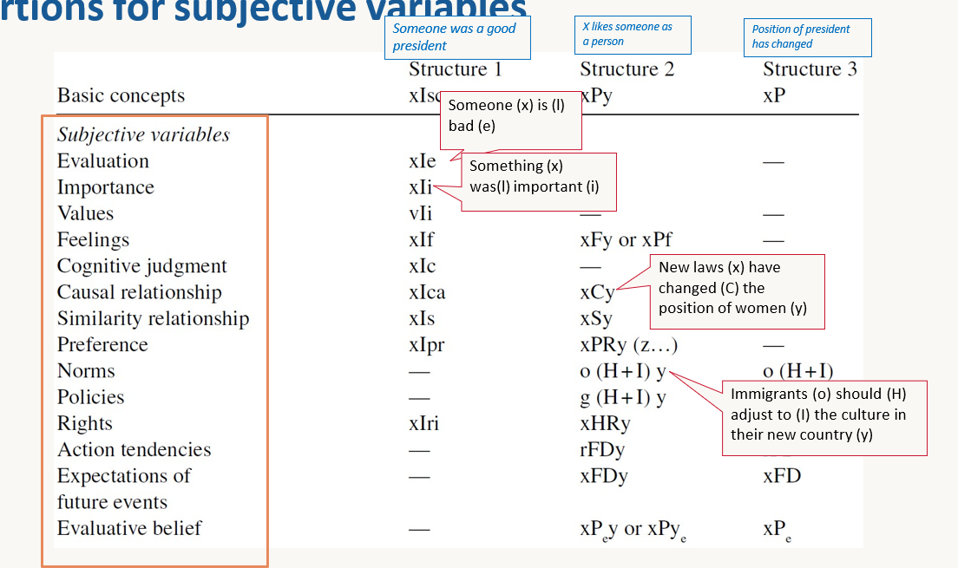

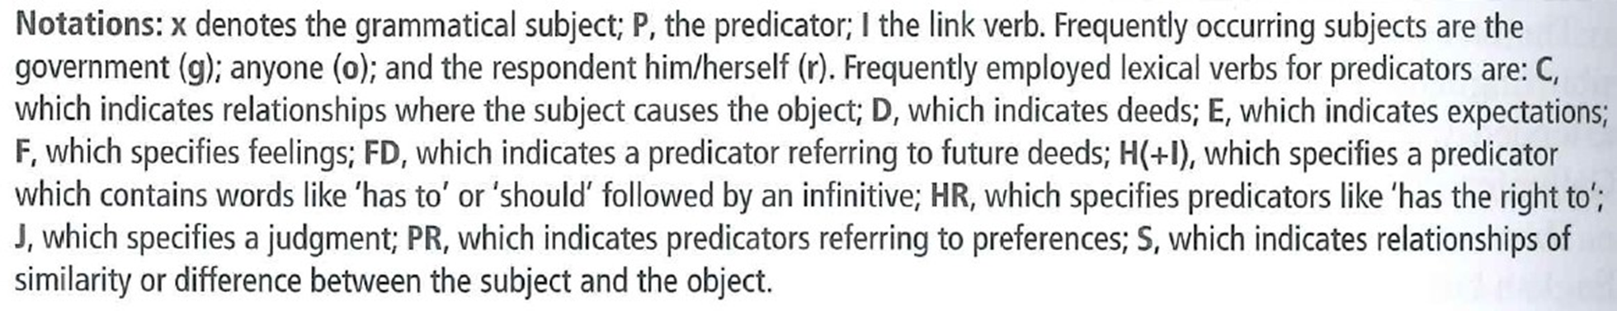
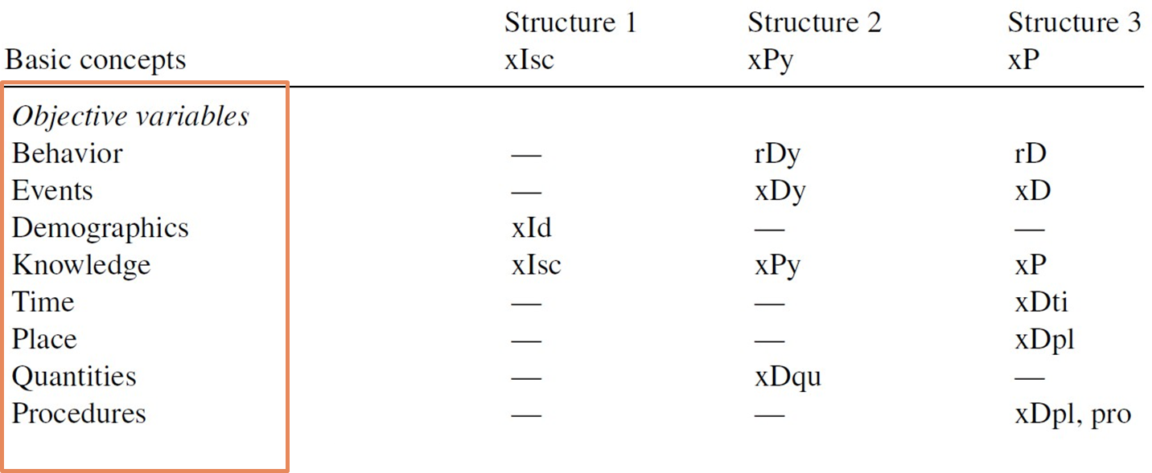

Evaluation criteria | Rather subjective or objective (1 very subjective to 5 very objective) | Question(s) for evaluation | Explanation
Identification of basic concept | 5 | Does the agent identify the basic concept correctly? | see list in screenshots above
Correct semantic structure | 5 | Does the agent follow the assertion template? | see list in screenshots above
Concept–assertion alignment | 4 | Does the assertion accurately represent the indicator from the previous step?

Output: One assertion per construct.

3. Development of requests for an answer from assertions

Input (real world): Assertion from step 2.

Input (evaluation): List of assertions covering all basic concepts with at least three examples.

Agent task: Take the assertion and make it a question (including answer options)

Evaluation criteria | Rather subjective or objective (1 very subjective to 5 very objective) | Question(s) for evaluation | Explanation
Question format | 5 | Which format is chosen?  Direct interrogative with or without a WH word  Direct imperative  Indirect interrogative  Indirect imperative | Example  Assertion:“ I am satisfied with my job”  Direct interrogative with or without a WH word:  Are you satisfied with your job? How satisfied are you with your job?  Direct imperative  Indicate your satisfaction with your job by a number between 0 and 10, where 0 means not at all satisfied and 10 means completely satisfied.  Indirect interrogative  Do you feel that you are satisfied with your job?  Indirect imperative  Please tell me how satisfied you are with your job?
Assertion–question alignment | 4 | Does the question accurately represent the assertion from the previous step?
Potentially also all evaluation questions from the next agent

Output: Questions incl. potential answer scale

Meeting Log
Date | Participants | Main topics | Key decisions | Next steps
29.05.2026 | Lanre, Rudraksha | LRZ account and next steps | - Correctness of data!! | - lrz access on monday: clear up  - Ask if we will be provided with examples for the concepts: we create our own test examples  - Data generation and collection (start next week)  - go though the material again  - agentic survey item generator: concept mapper  - what is our input as a concept?  - is it a particular concept or a survey topic? more diverse test data  - create excel with assertions and concepts (at least 3 examples)
01.06.2026 | Caro, Bolei, Rudraksha | Feedback on progress |  | - start with data creation- test set for assertions -> CI  - same concepts for both steps
08.06.2026 | Bolei, Lanre, Rudraksha | Feedback on data | - Train the models on Qwen3.5-9B | - Start with the training  - setup account for both Richie and Lanre (LRZ access)

1. Progress on Technical Set-up on LRZ

Current status
- LRZ setup done : access to storage

Completed tasks

Issues or blockers

Questions for Bolei and Caro

Decisions made

2. Progress on Design of the Agent

Current status

Prompting strategy

Questions for Bolei and Caro

Decisions made

3. Progress on the Design of the Evaluation and Creation of Test Data

Current status

Evaluation goals

Evaluation criteria or metrics

Test data

Questions for Bolei and Caro

Decisions made

Annotation Guide: Survey Item Gold Set
This guide defines how we fill every row so that both of us label the same way. It is also the first draft of the Assertion Developer prompt.

1. What an indicator is
An indicator is a short description of one concrete, measurable facet of a construct, specific enough that exactly one assertion can be written from it. It is the input the Assertion Developer receives, sitting between the abstract construct and the assertion.
A good indicator (checklist):
- names the subject (who or what is asked about: the respondent, the government, anyone)
- names the specific target or object
- names the dimension being measured, but does not yet phrase it as a statement (that is the assertion's job)
- is atomic: one thing, not two bundled together
Test: if an indicator could plausibly yield three different assertions, it is too vague. Tighten it.
Open question for Caro and Bolei: granularity. We are assuming the input is a single specific facet, not a broad survey topic. Confirm this; if they expect broad topics, indicators get coarser.

2. The chain every row follows
Construct (abstract) → indicator → assertion → question + answer options
Columns and who produces them:
- Input to Assertion Developer: input_indicator
- Gold the Assertion Developer must reproduce: basic_concept, semantic_structure, assertion
- Input to Question Developer: assertion
- Gold the Question Developer must reproduce: question, answer_options
- Metadata (no agent produces these): difficulty, domain, source_type, confusable_with, notes

3. Basic concepts (pick exactly one per row)
Subjective variables (14): Evaluation, Importance, Values, Feelings, Cognitive judgement, Causal relationship, Similarity relationship, Preference, Norms, Policies, Rights, Action tendencies, Expectations of future events, Evaluative belief
Objective variables (8): Behaviour, Events, Demographics, Knowledge, Time, Place, Quantities, Procedures

4. The three structures and per-concept codes
Every assertion fits one of three structures:
- Structure 1: xIsc (subject + link verb + characteristic), e.g. "Someone (x) is (I) bad (e)"
- Structure 2: xPy (subject + predicator + object), e.g. "X likes someone as a person"
- Structure 3: xP (subject + predicator), e.g. "Position of president has changed"
The dash means that structure is not used for that concept. Pick the structure that matches how the indicator is phrased.
Basic concept | Structure 1 | Structure 2 | Structure 3
Evaluation | xIe | — | —
Importance | xIi | — | —
Values | vIi | — | —
Feelings | xIf | xFy or xPf | —
Cognitive judgement | xIc | — | —
Causal relationship | xIca | xCy | —
Similarity relationship | xIs | xSy | —
Preference | xIpr | xPRy (z...) | —
Norms | — | o (H+I) y | o (H+I)
Policies | — | g (H+I) y | —
Rights | xIri | xHRy | —
Action tendencies | — | rFDy | —
Expectations of future events | — | xFDy | xFD
Evaluative belief | — | xP(e) y or xPy(e) | xP(e)
Behaviour | — | rDy | rD
Events | — | xDy | xD
Demographics | xId | — | —
Knowledge | xIsc | xPy | xP
Time | — | — | xDti
Place | — | — | xDpl
Quantities | — | xDqu | —
Procedures | — | — | xDpl, pro
In semantic_structure, record both the structure number and the code, e.g. "Structure 1 (xIe)".

5. Notation key
- x = grammatical subject; P = predicator; I = link verb
- Frequent subjects: g = government; o = anyone; r = the respondent (himself or herself)
- Predicator verb codes:
  - C = relationship where the subject causes the object
  - D = deeds
  - E = expectations
  - F = feelings
  - FD = future deeds
  - H(+I) = "has to" or "should" followed by an infinitive
  - HR = "has the right to"
  - J = a judgment
  - PR = preferences
  - S = similarity or difference between subject and object
Reading the lowercase suffix after I (e.g. the e in xIe): it abbreviates the basic concept that completes the assertion (e = evaluation term, i = importance, f = feeling, c = cognitive judgement, and so on). Treat this as the working reading and confirm edge cases against Saris & Gallhofer (2014).

6. Question formats (for the Question Developer column)
The same assertion can become any of four formats. Record which one in notes. Using "I am satisfied with my job":
- Direct interrogative (with or without a WH word): "Are you satisfied with your job?" / "How satisfied are you with your job?"
- Direct imperative: "Indicate your satisfaction with your job by a number between 0 and 10, where 0 means not at all satisfied and 10 means completely satisfied."
- Indirect interrogative: "Do you feel that you are satisfied with your job?"
- Indirect imperative: "Please tell me how satisfied you are with your job."

7. Worked rows (the reference standard)
Row A (Evaluation, subjective, Structure 1)
- input_indicator: how good a president someone was (respondent's evaluation)
- basic_concept: Evaluation
- semantic_structure: Structure 1 (xIe)
- assertion: Someone was a good president.
- question: How good a president was [name]? (direct interrogative, WH word)
- answer_options: 0 to 10, 0 = very bad, 10 = very good
- domain: politics
- confusable_with: Cognitive judgement
Row B (Feelings, subjective, Structure 1)
- input_indicator: how satisfied the respondent is with their job
- basic_concept: Feelings
- semantic_structure: Structure 1 (xIf)
- assertion: I am satisfied with my job.
- question: How satisfied are you with your job? (direct interrogative, WH word)
- answer_options: 0 to 10, 0 = not at all satisfied, 10 = completely satisfied
- domain: work
- confusable_with: Evaluation
Row C (Behaviour, objective, Structure 2)
- input_indicator: how often the respondent recycled household waste in the past month
- basic_concept: Behaviour
- semantic_structure: Structure 2 (rDy)
- assertion: I recycled household waste in the past month.
- question: How often did you recycle household waste in the past month? (direct interrogative, WH word)
- answer_options: never / rarely / sometimes / often / always
- domain: environment
- confusable_with: Action tendencies

8. Working heuristics for confusable concepts
These are starting rules to keep us consistent, to be confirmed with Caro. Log any contested call in notes.
- Evaluation vs Cognitive judgement: evaluation is a good/bad value placed on something; cognitive judgement is a factual belief about how something is, without the good/bad value.
- Feelings vs Evaluation: feelings use emotion words (satisfaction, fear, anger, hope); evaluation uses value words (good, bad, excellent).
- Behaviour vs Action tendencies: behaviour is something actually done (a past or habitual deed); action tendency is an inclination or readiness to act, not the act itself.
- Norms vs Policies: norms apply to anyone (o); policies are about what the government (g) should do.
When two concepts genuinely fit, pick the one the indicator emphasizes, record the alternative in confusable_with, and note the call.

